DAO’s

* AccountDAO
* JobListingDAO

Wrapper Classes

* Account
* JobListing
* Role

Traceability Diagram - DB Tables, DAO’s, and Wrappers to Entity Classes

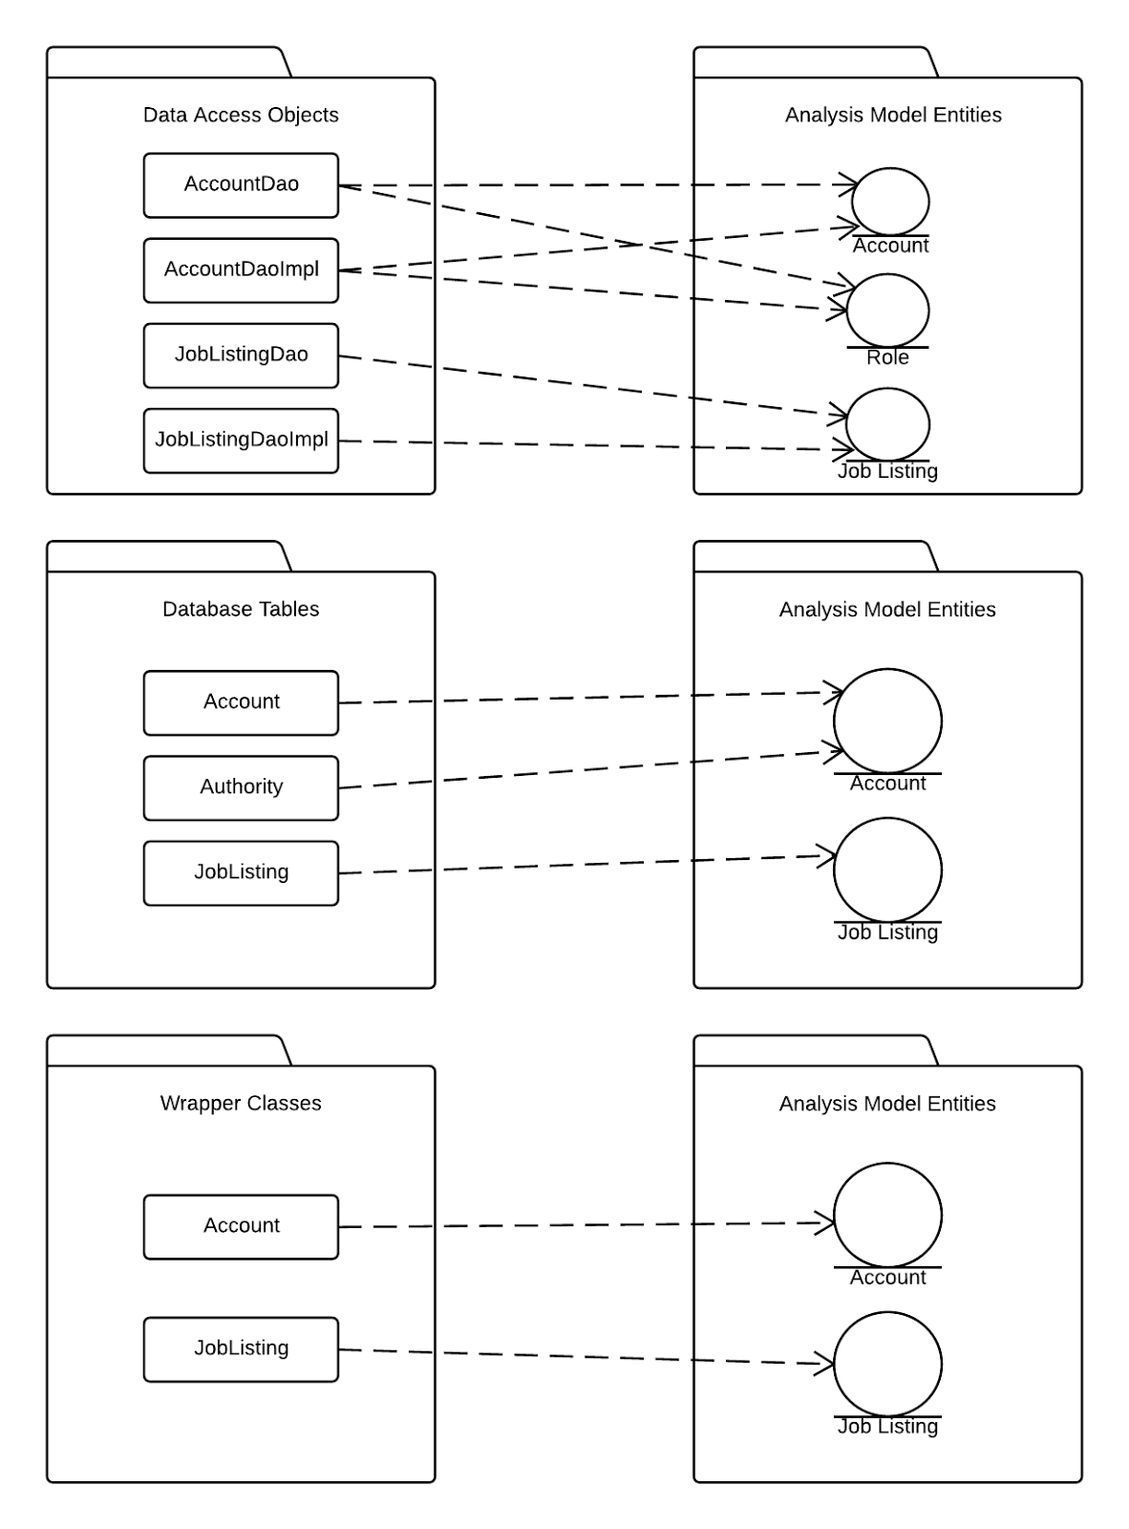

Traceability Diagram - Controllers to Dispatchers

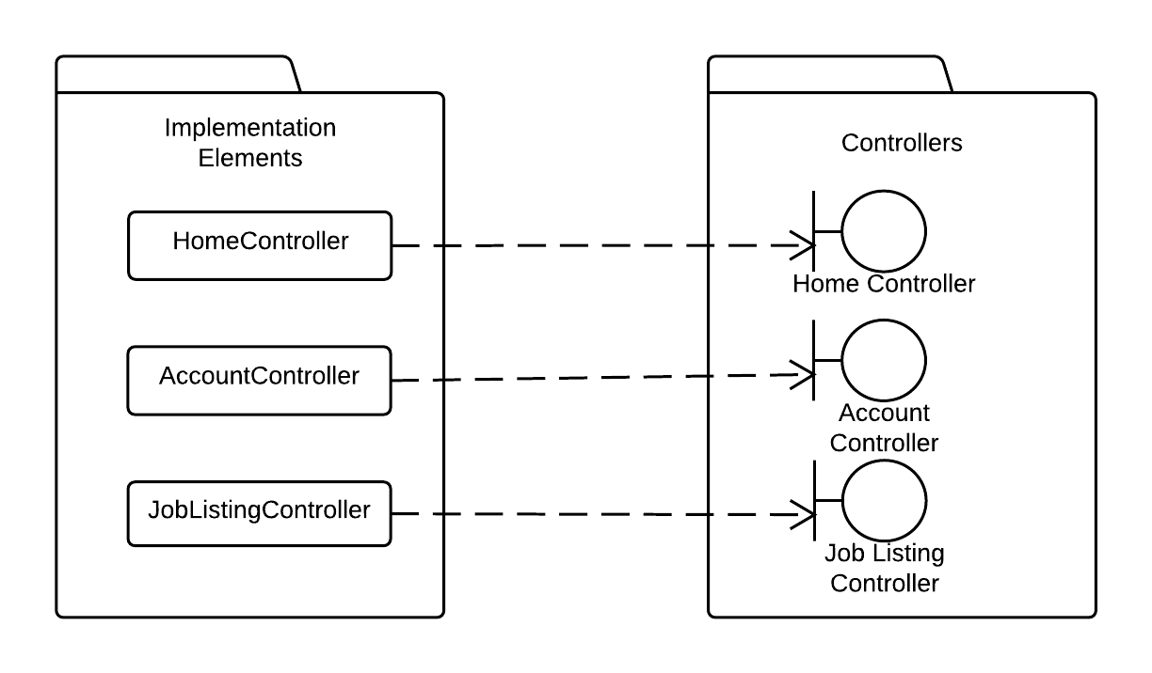

Traceability Diagram - Services to Entity Manager

